
Dedan Kimathi University of Technology
School of Computer Science and Information Technology.
Information Technology Department

AUTOMATED LIBRARY SEAT TRACKING SYSTEM
C025-01-0602/2023
Emmanuel Kalongo Dena

The final project proposal submitted in partial requirement for the degree in Bachelor of Science in Information Technology

JULY, 2027

DECLARATION
I, Emmanuel Kalongo Dena, hereby declare that this project proposal titled “Automated Library Seat Tracking System” is my original work. It has not been submitted for any other degree, diploma, or certificate at this or any other university. All sources of information used in this proposal have been duly acknowledged.
Signature:
Date:

Supervisor's Declaration
This project proposal has been submitted for examination with my approval as the University Supervisor.
Name: Md Hellen Mwangi.
Signature:
Date:

ABSTRACT
Students at Truna University waste a lot of time walking to the library just to check if there are empty seats. Sometimes you get lucky, sometimes you don’t. This proposal outlines a system that tracks library seats automatically using sensor simulation. The main goal is to build a web-based system where students can check live seat availability on their phones before leaving their hostels. The system will also show available e-books and online resources so remote students can access them easily. The project will adopt an Agile development methodology to allow for iterative feedback and rapid prototyping. The system will be developed using the Flask framework (Python) for the backend, SQLite for the database and HTML/CSS for the user interface. The expected outcome is a fully functional, user-friendly web application that reduces student time wasted, provides real-time seat availability, improves resource allocation and enhances remote access to e-resources. This project is significant for universities seeking affordable digital solutions to improve campus resource management.

Contents
Truna AUTOMATED LIBRARY SEAT TRACKING SYSTEM 1
DECLARATION 2
Supervisor's Declaration 2
ABSTRACT 3
LIST OF FIGURES 7
LIST OF TABLES 7
LIST OF ACRONYMS/ABBREVIATIONS 7
CHAPTER 1: INTRODUCTION 9
1.1 Background of the Study 9
1.2 Problem Statement 9
1.3 Aims and Objectives 10
1.3.1 Main Objective 10
1.3.2 Specific Objectives 10
1.4 Scope and Limitations 11
Scope 11
Limitations 11
1.5 Significance of the Study 11
1.6 Chapter Summary 12
Chapter 2: LITERATURE REVIEW 13
2.1 Introduction 13
2.2 Case Studies 13
2.2.1 Case Study 1: Queue Management in Kenyan Universities 13
2.2.2 Case Study 2: Library Seat Usage Patterns 13
2.2.3 Case Study 3: Campus Space Usage in American Universities 13
2.2.4 Case Study 4: Remote Learning Challenges 14
2.3 Research Gap 14
2.4 Chapter Summary 14
Chapter 3: SYSTEM METHODOLOGY AND DESIGN 15
3.1 Introduction 15
3.2 Project Methodology 15
Phase 1: Setup and basic system 15
Phase 2: Sensor Integration and Core Features 15
Phase 3: ML Integration 15
Phase 4: Testing and Refinement 15
Phase 5: Documentation 15
Testing Strategy 16
3.3 System Architecture 16
a. Sensor/Sensor Simulation Input 16
b. Backend (Flask App) 16
c. Database (SQLite) 16
d. Frontend (Student Dashboard) 16
e. Client-Side Interaction 17
f. Admin Panel 17
Data Flow 17
Deployment 17
3.4 Requirement Analysis 19
3.4.1 Functional Requirements 19
3.4.2 Non-Functional Requirements 20
3.5 User Interface Design 20
3.5.1 Student Dashboard Mockup 20
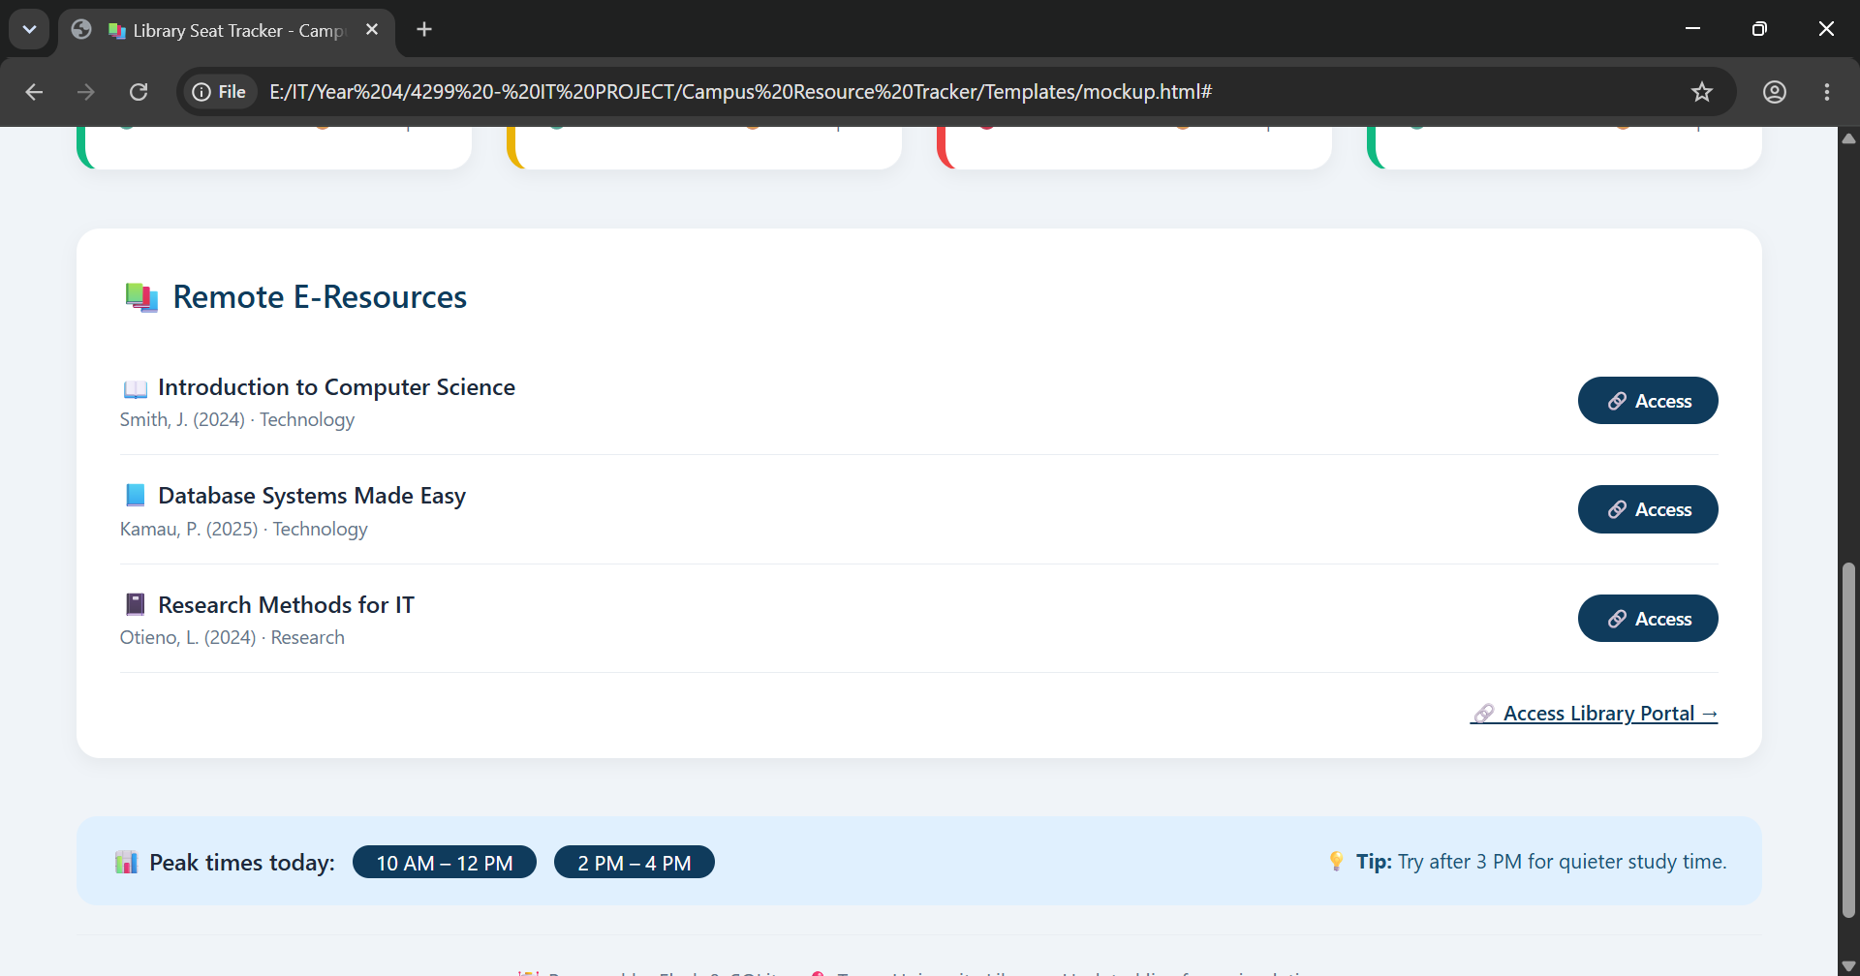 21
3.5.2 Client-Side Interaction (JavaScript) 22
3.6 Database Design 22
3.6.1 Entity-Relationship (ER) Diagram 22
1. Resource 22
2. ResourceHistory 22
3. EBook 22
3.6.2 Schema Tables 23
Resource Table 23
ResourceHistory Table 23
EBook Table 23
24
3.7 Project Management Tools 25
3.7.1 Project Schedule 25
3.7.2 Expected Budget 25
3.8 Chapter Summary 25
REFERENCES 26

LIST OF FIGURES
Figure 1 System Architecture Diagram 17
Figure 2 Student Dashboard 20
Figure 3 Entity-Relationship Diagram 23

LIST OF TABLES
Table 1 Functional Requirements Specifications 18
Table 2 Non-Functional Requirements Specifications 18
Table 3 JavaScript table 20
Table 4 Resource Table Schema 22
Table 5 ResourceHistory Table Schema 22
Table 6 EBook Table Schema 22

LIST OF ACRONYMS/ABBREVIATIONS
Acronym Full Form
API Application Programming Interface
DBMS Database Management System
ERD Entity-Relationship Diagram
HTML Hypertext Markup Language
HTTP Hypertext Transfer Protocol
ICT Information and Communication Technology
IT Information Technology
ML Machine Learning
SQL Structured Query Language
UI User Interface
UX User Experience
MVC Model-View-Controller
SDLC Software Development Life Cycle
PIR Passive Infrared (sensor)

CHAPTER 1: INTRODUCTION

1.1 Background of the Study
University libraries are supposed to be places where students go to study, read and get work done. But at Truna University, one of the biggest problems students face is finding an empty seat. You walk to the library only to find it full then you walk to another floor and sometimes you just give up and go back to your room. It wastes time, especially during exams when you actually need to study.
I have experienced this myself so many times. I’ve also talked to other students and they all say the same thing. The library has no system that shows how many seats are available at any given time, so you have no choice but to physically go and check. Another issue is that students who are off-campus or studying remotely struggle to access e-books and online resources because they don’t know what’s available or how to get to them.
My project tries to fix both of these problems. I’m building a system that automatically tracks how many people are in the library using sensors (or a simulation that works just like sensors). Students can open a dashboard on their phones and see which sections have available seats before they even leave their hostels. The same dashboard will also list available e-books and online resources so remote students can access them too. The system will also save data over time and use machine learning to predict when the library is usually busy, so students can plan their visits better.

1.2 Problem Statement
Right now, if a student wants to study in the library, they have to walk there first just to check if there’s space. Sometimes you get lucky, sometimes you don’t. if it’s full, you either wait around or go somewhere else or back to your hostel. There’s no way to know beforehand. The library has no system that tells you how many seats are occupied. Nobody knows which floors are busiest or when peak hours are. And for students who are off campus, it’s even worse – they can’t easily access e-books or online journals because the library’s digital resources are not easy to find or browse.
This wastes a lot of time. Walking to the library to check if there’s space takes about 20 to 30 minutes each time. That adds up quickly, especially during exam season when every minute counts. Students lose study time because they can’t find a seat. Some students just give up and go back to their hostels, but not everyone has a quiet place to study. The library staff also don’t have any data to show when the library is most crowded or if they need more seats. Remote students are left out because they can’t easily access digital resources. Right now, the library relies on word of mouth and paper sign-in sheets, which don’t work in real time. In addition to that they tally how many students are in the library at hour time intervals.
My project solves this by building a fully automated library seat tracking system. Sensors at the library entrance will detect when students enter and leave, automatically updating seat counts in real-time. Students open a simple dashboard on their phones to see live availability for different sections of the library – Main floor, upper floor, computer lab and study rooms. The same dashboard also shows a list of available e-books and online resources, so remote students can access digital materials from anywhere. The system stores data over time and uses machine learning to predict busy hours, helping students plan when to visit. The dashboard uses a clean, card-based layout so students can quickly see what’s available at a glance.

1.3 Aims and Objectives

1.3.1 Main Objective
The main objective of this project is to design and develop a fully automated library seat tracking system that shows real-time seat availability, stores historical usage data and integrate e-resource access for remote students.

1.3.2 Specific Objectives
- To build a live seat availability dashboard that shows real-time counts for library sections (Main floor, Upper floor, Computer lab, Study rooms) with color-coded status indicators ( Available, Almost full, Full) so it’s easy to understand at a glance.
- To integrate simulation input that automatically updates seats counts by processing “ENTRY” and “EXIT” events so staff don’t have to do it manually.
- To store historical data every time a seat count changes, so I can track patterns of when the library is busy.
- To integrate e-book and e-resource access into the student dashboard with a searchable list of online books, journals and databases.
- To provide direct links to the library’s remote access portal so off-campus students can log in and access restricted resources.

1.4 Scope and Limitations

Scope
This project covers the design and development of an automated library seat tracking system for Truna University. The system includes a student dashboard showing live seat counts, a simulation script for automated updates, a database for storing current and historical data and e-resource integration. The system runs locally on a laptop and does not need internet for hosting.

Limitations
The system currently uses a simulation mode instead of real sensors. Physical sensors can be added later if the university wants to implement them. The e-resource integration provides links and metadata but doesn’t host the actual content. The system is designed for one library with multiple sections and may need changes for other campuses.

1.5 Significance of the Study
This project is important for several reasons. For students, it saves time by letting them check seat availability before leaving their hostels. For library staff, it provides real-time data on library usage, helping them manage resources better. For remote students, it improves access to e-books and online resources. For the university, it offers a low-cost solution that can be adapted to other facilities like computer labs and study rooms. It also contributes to understanding how simple automation can improve campus resource management.

1.6 Chapter Summary
This chapter introduced the problem of finding available library seats and the lack of systems to track occupancy. It outlined the project’s objectives: to build a live dashboard, automate seat counts using simulation, store historical data and integrate e-resource access. The scope was defined as a local system for Truna University with simulation mode. The significance of the project for students, staff and the university was discussed.

Chapter 2: LITERATURE REVIEW

2.1 Introduction
This chapter reviews existing work on campus resource management, e-resource access and software systems. It discusses case studies of similar systems, highlights their strengths and weaknesses and identifies gaps that this project seeks to fill.

2.2 Case Studies

2.2.1 Case Study 1: Queue Management in Kenyan Universities
Kamau and Otieno (2025) looked at queue management in Kenyan universities and found that students waste 15-20 minutes per day just waiting for services, including library seating. They proposed a mobile app with Bluetooth sensors but those sensors were too expensive for most universities.
Strengths: The study identified a real problem and proposed a tech solution.
Weaknesses: The solution was too expensive to actually implement.
Relevance to My Project: My project uses a software-first approach with simulation, making it cheaper and more practical.

2.2.2 Case Study 2: Library Seat Usage Patterns
Mwangi et al. (2024) studied library seat usage at a Kenyan university and found that peak usage happens between 2pm to 5pm. They recommended real-time availability systems but didn’t build one.
Strengths: The study provided useful data on when students use the library.
Weaknesses: They didn’t actually build the system they recommended.
Relevance to My Project: My project will build what they suggested.

2.2.3 Case Study 3: Campus Space Usage in American Universities
A study on campus space usage in American universities (2019) found that students’ decisions about where to spend time on campus are influenced by convenience and real-time information. Students are more likely to use facilities when they can check availability first.
Strengths: The study showed that real-time information changes student behavior.
Weaknesses: It was done in a different context with more resources.
Relevance to My Project: It supports my idea that students would actually use a live dashboard.

2.2.4 Case Study 4: Remote Learning Challenges
Ochieng and Kiprop (2024) looked at remote learning challenges in Kenyan universities and found that off-campus students often struggle to access library e-resources because they’re not easy to find. A UNESCO report (2025) highlighted the importance of making online resources accessible to all students.
Strengths: The studies identified a real gap in access.
Weaknesses: They didn't propose specific solutions.
Relevance to My Project: My project puts e-book access directly on the dashboard, making it easier to find.

2.3 Research Gap
Most existing systems are either too expensive (requiring complex sensors) or too manual (relying on staff updates). Few systems combine seat tracking with e-resource access in one place. My project fills this gap by providing a fully automated software solution that can work with simulation now and connect to real sensors later.

2.4 Chapter Summary
This chapter reviewed existing work on campus resource management, e-resource access, and software systems. Four case studies were analyzed, highlighting their strengths and weaknesses. The research gap was identified as a lack of affordable, automated systems that combine seat tracking with e-resource access. My project fills this gap.

Chapter 3: SYSTEM METHODOLOGY AND DESIGN

3.1 Introduction
This chapter describes how I plan to build the Automated Library Seat Tracking System. It covers the project methodology, system architecture, requirement analysis, user interface design, database design, and project management tools.

3.2 Project Methodology
I’ll use Agile development methodology for this project. Agile allows me to build things step by step and get feedback along the way, which works well for a university project where requirements might change.
Phases:

Phase 1: Setup and basic system
I’ll set up Flask, SQLite and create the database models. I’ll build a basic dashboard to confirm everything works. I’ll also create the sensor simulation script.

Phase 2: Sensor Integration and Core Features
I’ll integrate the simulation mode with the backend. When events are received, the backend will update the database automatically. I’ll also add the e-resource feature and history logging. I’ll test the system by running the simulation and watching the counts update on the dashboard.

Phase 3: ML Integration
I’ll train a simple model using scikit-learn to predict busy hours using the history data. I’ll integrate the predictions into the dashboard.

Phase 4: Testing and Refinement
I'll test everything thoroughly. I'll ask the librarian and 5 students to test the dashboard and give feedback. I'll fix bugs and refine the UI.

Phase 5: Documentation
I'll write a user guide and technical report. I'll prepare for final presentation.

Testing Strategy
I'll use PyTest for backend testing. For the frontend, I'll manually test by clicking through. I'll also test the simulation mode to ensure it correctly updates the dashboard.

3.3 System Architecture
My system has six main parts:

Sensor/Sensor Simulation Input
The system accepts data from a simulation script. In simulation mode, a Python script generates random events that mimic real traffic patterns. Each entry subtracts one from the available count; each exit adds one back.

Backend (Flask App)
Flask receives sensor events, processes them to update seat counts and saves every event to the database. It also handles requests from the dashboard and serves the ML predictions.

Database (SQLite)
I’ll use SQLite because it doesn’t need a separate server. The database has three tables:
- Resource – current seat counts for each section
- ResourceHistory - every entry/exit event with timestamps
- EBook – list of available e-books and online resources

Frontend (Student Dashboard)
The dashboard shows live counts for each library section as cards with:
- Section name and icon
- Available seat counts
- Color-coded status ( Available, Almost Full, Full)
- Last updated time
The e-resource section displays e-book titles, authors, links and categories

Client-Side Interaction
To make the dashboard interactive, JavaScript is used on the client side. It handles:
- Real-time search filtering by section name
- Dropdown filtering by section
- Reset filters (“View all”)
- “Check Availability” confirmation
- Navigation to admin panel
- E-Resource access actions
The JavaScript communicated with the Flask backend only when necessary (e.g., when the admin panel is accessed), otherwise all interactions happen instantly on the client side without page reloads.

Admin Panel
It allows staff to manually update seat counts, add/remove e-resources and view historical data.
Why: Manual update option as a fallback — in case the simulation stops or needs correction.

Data Flow
When a student enters in simulation mode, the script sends “ENTRY” to Flask. Flask subtracts 1 from the count, saves the event to ResourceHistory and updates the dashboard instantly. When a student opens the dashboard, Flask reads the current counts from the Resource table and displays them.

Deployment
The system runs on my laptop with simulation mode.

Figure 1 System Architecture Diagram
Flask Backend
Handles request
Processes sensor events
Runs ML predictions
Database (SQLite)
Resource
History
EBooks
Simulation Script
Generates ENTRY/EXIT events
CAMPUS RESOURCE TRACKER
SYSTEM FLOW

Student (on phone)
Student Dashboard
Live seat counts
Color-coded status
E-Book list
Peak hour predictions

External Access (Remote)
Links to library portal
Open access e-resources

3.4 Requirement Analysis

3.4.1 Functional Requirements
Table 1 Functional Requirements Specifications
Requirement ID | Description | Priority
FR-01 | The system must show live seat counts for each library section | High
FR-02 | The system must update seat counts automatically when ENTRY or EXIT events are received | High
FR-03 | The system must store historical data for every seat count change | High
FR-04 | The system must display a list of available e-books and online resources | High
FR-05 | The system must provide links to the library’s remote access portal | Medium
FR-06 | The system must show color-coded status indicators (Available, Almost Full, Full) | High
FR-07 | The system must show when counts were last updated | High

3.4.2 Non-Functional Requirements
Table 2 Non-Functional Requirements Specifications
Requirement ID | Description | Priority
NFR-01 | The dashboard must work on mobile phones | High
NFR-02 | The dashboard should load within 3 seconds | Medium
NFR-03 | The system must work without internet (local deployment) | High
NFR-04 | The system must not store personal student data | High

3.5 User Interface Design

3.5.1 Student Dashboard Mockup
The dashboard will show seat counts for each library section using a card-based layout. Each card shows the section name, available seats, color-coded status, and last updated time. Below the cards, there will be a list of available e-resources.
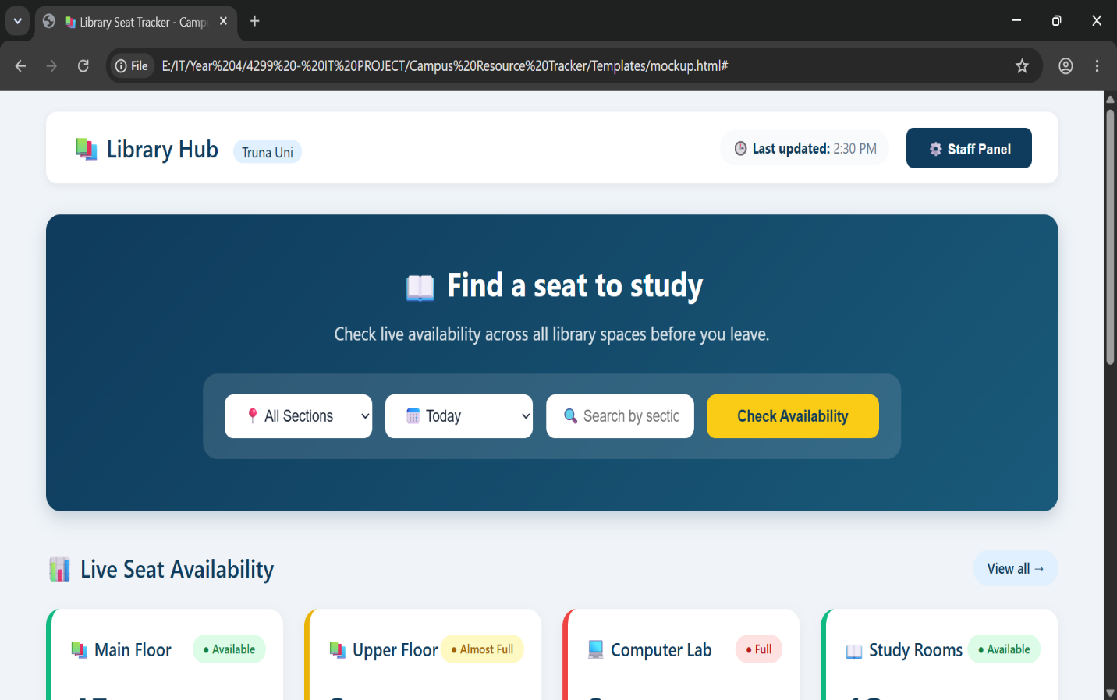


Figure 2 Student Dashboard

3.5.2 Client-Side Interaction (JavaScript)
To make the dashboard interactive and responsive to user actions, I will use JavaScript. The following functionalities will be implemented on the client side:
Table 3 JavaScript table
Feature | Description
Filter by section | Dropdown menu allows filtering by specific sections
“View all” reset | Resets all filters and shows all sections
Check Availability | Confirms availability check and resets filters
Staff Panel link | Navigates to the admin panel
E-Resource access | Opens resource links or shows confirmation

3.6 Database Design

3.6.1 Entity-Relationship (ER) Diagram
The database has three main tables:

Resource
- Id (INTEGER, PRIMARY KEY) – Unique ID for each section
- Name (TEXT) – Section name (e.g., “Main Library”)
- Available (INTEGER) – current available seats
- Last_updated (DATETIME) – when it was last updated

ResourceHistory
- Id (INTEGER, PRIMARY KEY) – unique id
- Resource_id (INTEGER, FOREIGN KEY) – references resource
- Old_count (INTEGER) – previous seat count
- New_count (INTEGER) – new seat count
- Event_type (TEXT) – ‘ENTRY’ or ‘EXIT’
- Changed_at (DATETIME) – when the change happened

EBook
- Id (INTEGER, PRIMARY KEY) – unique id
- Title (TEXT) – E-Book title
- Author (TEXT) – author name
- Category (TEXT) – subject category
- Link (TEXT) – URL to access
- Is_open_access (INTEGER) – 1 if free, 0 if login required

3.6.2 Schema Tables

Resource Table
Table 4 Resource Table Schema
Column | Type | Description
id | INTEGER | Unique ID
Name | TEXT | Section name
Available | INTEGER | Available seats
Last_updated | DATETIME | Last updated time

ResourceHistory Table
Table 5 ResourceHistory Table Schema
Column | Type | Description
id | INTEGER | Unique ID
Resource_id | INTEGER | Reference Resources
Old_count | INTEGER | Previous count
New_count | INTEGER | New count
Event_type | TEXT | ENTRY or EXIT
Changed_at | DATETIME | Timestamp

EBook Table
Table 6 EBook Table Schema
Column | Type | Description
Id | INTEGER | Unique ID
Title | TEXT | E-Book title
Author | TEXT | Author name
Category | TEXT | Subject category
Link | TEXT | Access URL
Is_open_access | INTEGER | Free access flag

ResourceHistory
Id
Resource_id
Old_count
New_count
Event_type
Changed_at
Resource
Id
Name
Available
Last_updated
1 to many

EBook
Id
Title
Author
Category
Link
Is_open_access

RELATIONSHIPS
RESOURCE (1) (MANY) RESOURCE_HISTORY
Each resource (library section) can have many history records tracking seat changes over time.
EBOOK (independent) – no direct relationship with RESOURCE or RESOURCE_HISTORY. It exists as a separate entity for e-resource management.

Figure 3 Entity-Relationship Diagram

3.7 Project Management Tools

3.7.1 Project Schedule
July: Setup Flask, SQLite, basic dashboard, simulation script
August: Complete dashboard, sensor integration, history logging, e-resource feature
September: Train ML model, integrate predictions into dashboard
October: Test, get user feedback, fix bugs, refine UI
November: Write user guide, technical report, prepare for defense
December: Final submission, oral defense

3.7.2 Expected Budget
My project will cost nothing. Here’s why:
- Flask and SQLite are free and open source
- I run everything on my laptop, no hosting fees
- I’m not using any paid APIs
- VS Code is free
- I can back up my code on Google Drive for free
- All libraries I use are free

3.8 Chapter Summary
This chapter described how I plan to build the system. I'll use Agile development with five phases. The system architecture includes simulation input, Flask backend, SQLite database, and student dashboard. I listed the requirements, showed the dashboard design, and explained the database tables. The schedule and budget were also covered.

REFERENCES
Kamau, J., & Otieno, P. (2025). Queue management in Kenyan universities. East African Journal of Computing, 8(2), 34-42.
Mwangi, S., et al. (2024). Library seat usage patterns at University of Nairobi. Kenyan Journal of Information Science, 12(1), 45-53.
Ochieng, M., & Kiprop, D. (2024). Remote learning challenges in Kenyan universities. African Journal of Education and Technology, 5(3), 78-89.
UNESCO. (2025). Digital education in Africa: Progress and challenges. UNESCO Publishing.
Flask Documentation. (2026). Flask Web Development. https://flask.palletsprojects.com
SQLite Documentation. (2026). SQLite Home Page. https://sqlite.org
Scikit-learn Documentation. (2026). Linear Regression Example. https://scikit-learn.org
Real Python. (2025). Python Web Applications with Flask. https://realpython.com
Mozilla Developer Network. (2026). JavaScript Documentation. https://developer.mozilla.org/en-US/docs/Web/JavaScript
OpenAI. (2026). ChatGPT (July 2026 version). Used for brainstorming topic ideas

